**Assignment Date: 22-09-2022**

**Name : Vaishnavi R**

**Reg No :111519106164**

**Maximum Marks:2Marks**

**Question**

ASSIGNMENT 2: VAISHNAVI R(111519106164)

Build a python code by assumming temperature and humidity values using random function .And write a condition to continuously buzz an alarm in case of high temperature.

CODE:

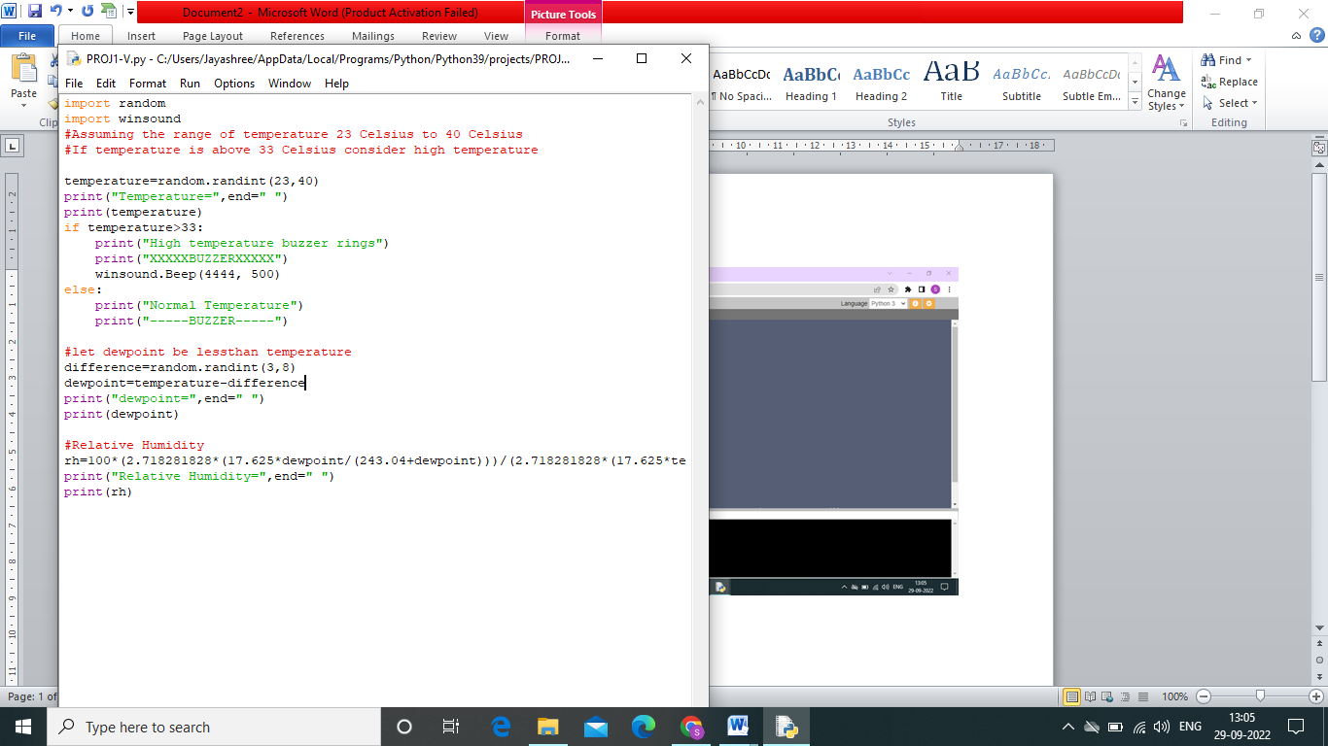

OUPUT:

